**Assignment 2**

**Shashwat Tripathi**

**D20A 64**

**1. Explain data validation and why is it important for a secure software application.**

**Data validation** is the process of ensuring that the input data to a software application meets certain criteria for type, format, range, and completeness before processing it. This is a crucial step in the software development lifecycle that helps to ensure the integrity and security of the application.

**Importance of Data Validation**:

* **Prevention of Injection Attacks**: Data validation helps to mitigate risks associated with SQL injection, cross-site scripting (XSS), and other injection attacks by ensuring that inputs conform to expected formats and values.
* **Data Integrity**: By validating inputs, applications can ensure that only meaningful and correct data is processed, which is vital for maintaining data integrity and accuracy.
* **Improved User Experience**: Proper data validation can provide instant feedback to users regarding the correctness of their inputs, improving overall user experience.
* **Regulatory Compliance**: Many industries have compliance requirements (like HIPAA, PCI-DSS) that mandate the validation of data to protect sensitive information.
* **Reduction of Software Bugs**: Validating inputs helps catch errors early, reducing the likelihood of bugs that could be exploited by malicious actors.

In summary, data validation is essential for maintaining security, integrity, and usability in software applications, preventing a range of vulnerabilities and ensuring compliance with industry standards.

**2. Explain session management in a web application.**

**Session management** refers to the process of handling user sessions in web applications, ensuring that a user remains authenticated and that their interactions are tracked securely throughout their time on the site. It involves creating, maintaining, and terminating sessions in a way that protects user data and prevents unauthorized access.

**Key Aspects of Session Management**:

* **Session Creation**: When a user logs in, a session is created and a unique session identifier (ID) is generated. This ID is typically stored on the server and sent to the user's browser as a cookie.
* **Session Tracking**: The application must track active sessions using session IDs to associate user requests with the correct session data. This can be done via cookies, URL parameters, or hidden form fields.
* **Session Security**: Protecting session data is critical. This involves:
  + **Using HTTPS**: Secure communication channels prevent session hijacking.
  + **Setting Session Timeouts**: Automatically logging users out after a period of inactivity reduces the risk of unauthorized access.
  + **Regenerating Session IDs**: Changing session IDs after successful login helps prevent session fixation attacks.
  + **Validating User Actions**: Ensuring that actions taken during a session are authorized and legitimate.

Effective session management is crucial for protecting user data, maintaining user authentication, and enhancing the overall security posture of web applications.

**3. Describe buffer overflow attack and explain mechanism the mechanism to handle it.**

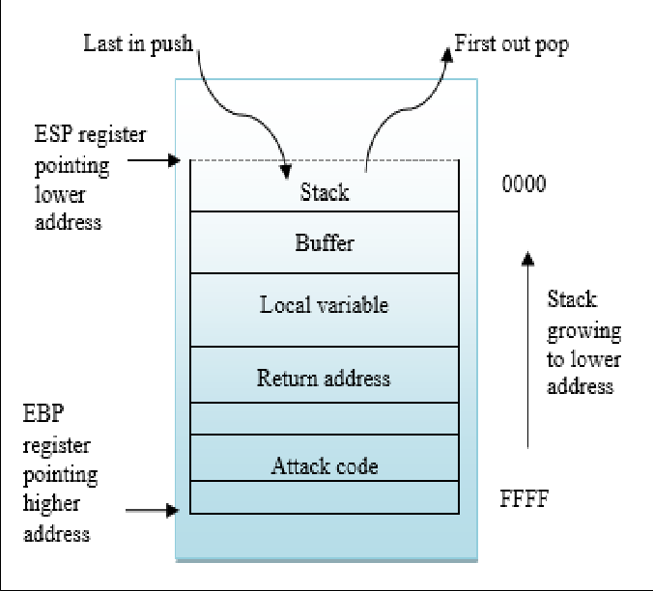

A **buffer overflow attack** occurs when a program writes more data to a block of memory (buffer) than it was allocated for. This excess data can overwrite adjacent memory, potentially leading to unpredictable behavior, data corruption, or execution of arbitrary code.

**Mechanism of Buffer Overflow**:

1. **Excess Data Input**: The attacker inputs data larger than the buffer's capacity.
2. **Overwriting Memory**: The extra data overwrites adjacent memory, which can include control data like function return addresses.
3. **Exploitation**: By overwriting the return address, the attacker can redirect execution flow to malicious code they have injected into the program, gaining control over the system.

**Mechanisms to Handle Buffer Overflow**:

* **Input Validation**: Ensuring that inputs do not exceed expected limits. This involves checking the length of user inputs and rejecting excessively long data.
* **Use of Safe Functions**: Utilizing functions that limit the amount of data written to buffers (e.g., strncpy instead of strcpy in C).
* **Stack Canaries**: Inserting a known value (canary) before the return address on the stack. If a buffer overflow occurs, the canary value will change, signaling an attack and preventing the program from executing.
* **Address Space Layout Randomization (ASLR)**: Randomizing memory addresses to make it more difficult for attackers to predict where their malicious code will be executed.
* **Data Execution Prevention (DEP)**: Marking areas of memory as non-executable to prevent code execution from data segments, thereby blocking arbitrary code execution.

By implementing these measures, developers can significantly reduce the risk of buffer overflow attacks.

**4. Explain some tools which can be used to check the vulnerability of an application.**

Several tools are available for checking the vulnerabilities of applications, each serving different purposes in the security assessment process:

1. **Burp Suite**:
   * A comprehensive web vulnerability scanner that allows security professionals to intercept and analyze web traffic. It can identify vulnerabilities such as SQL injection, cross-site scripting (XSS), and more. The tool also provides manual testing capabilities.
2. **OWASP ZAP (Zed Attack Proxy)**:
   * An open-source web application security scanner that helps find vulnerabilities in web applications during development and testing. It features automated scanners and various tools for manual testing.
3. **Nessus**:
   * A widely-used vulnerability scanner that identifies security vulnerabilities, misconfigurations, and compliance issues in systems and applications. Nessus offers comprehensive reporting and remediation guidance.
4. **Nikto**:
   * An open-source web server scanner that tests for various vulnerabilities and outdated server software. It checks for common issues like misconfigurations and security holes in web servers.
5. **Fortify Static Code Analyzer**:
   * A static application security testing (SAST) tool that analyzes source code for security vulnerabilities without executing it. It helps identify issues in the early stages of development, making it easier to fix vulnerabilities before deployment.
6. **Acunetix**:
   * A web application security scanner that detects vulnerabilities such as SQL injection and XSS. It features automated scanning, detailed reporting, and integration with CI/CD pipelines for continuous security.

Using these tools, organizations can proactively identify and address vulnerabilities, enhancing the overall security of their applications.

**5. How hashing algorithms termed as secure for data? Highlight some of the methods to achieve it.**

**Hashing algorithms** are termed secure when they provide certain guarantees regarding the integrity and confidentiality of the data being hashed. A secure hashing algorithm transforms input data into a fixed-size string of characters, which appears random.

**Characteristics of Secure Hashing Algorithms**:

1. **Deterministic**: The same input always produces the same output.
2. **Pre-image Resistance**: It should be computationally infeasible to reverse the hashing process, meaning given a hash value, it should be difficult to find the original input.
3. **Collision Resistance**: It should be challenging to find two different inputs that produce the same hash value. This prevents attackers from substituting one piece of data for another without detection.
4. **Avalanche Effect**: A small change in input should result in a significantly different hash output.

**Methods to Achieve Secure Hashing**:

* **Use of Strong Hash Functions**: Algorithms like SHA-256, SHA-3, or Bcrypt provide high levels of security. Older algorithms like MD5 and SHA-1 are considered weak due to vulnerabilities that allow for collision attacks.
* **Salting**: Adding a unique random string (salt) to the input before hashing enhances security by preventing precomputed attacks like rainbow tables, which are used to reverse-engineer hashes.
* **Keyed Hashing**: Using a secret key with the hashing algorithm (HMAC - Hash-based Message Authentication Code) adds an additional layer of security, ensuring that only those with the key can verify the integrity of the hash.
* **Regular Algorithm Updates**: Staying updated with current best practices and adapting to advancements in cryptography helps ensure continued security.